
Dynamic profiling

*Superuser permissions are required to profile

Tools used – perf,gprof

Setting up/Installation

#installing perf
sudo apt-get update
sudo apt-get install linux-tools-common linux-tools-generic
sudo apt-get install linux-tools-6.2.0-39-generic
sudo apt-get install linux-tools-6.5.0-14-generic linux-cloud-tools-6.5.0-14-generic
sudo apt-get install linux-tools-generic linux-cloud-tools-generic
sudo apt-get install linux-tools-generic
perf –version

#installing Flamegraph
git clone https://github.com/brendangregg/FlameGraph
cd FlameGraph
chmod +x stackcollapse-perf.pl flamegraph.pl

Perf Tool

For running exes which do not exit
Terminal 1:

Running Exe:
Exe running

Command: ./example

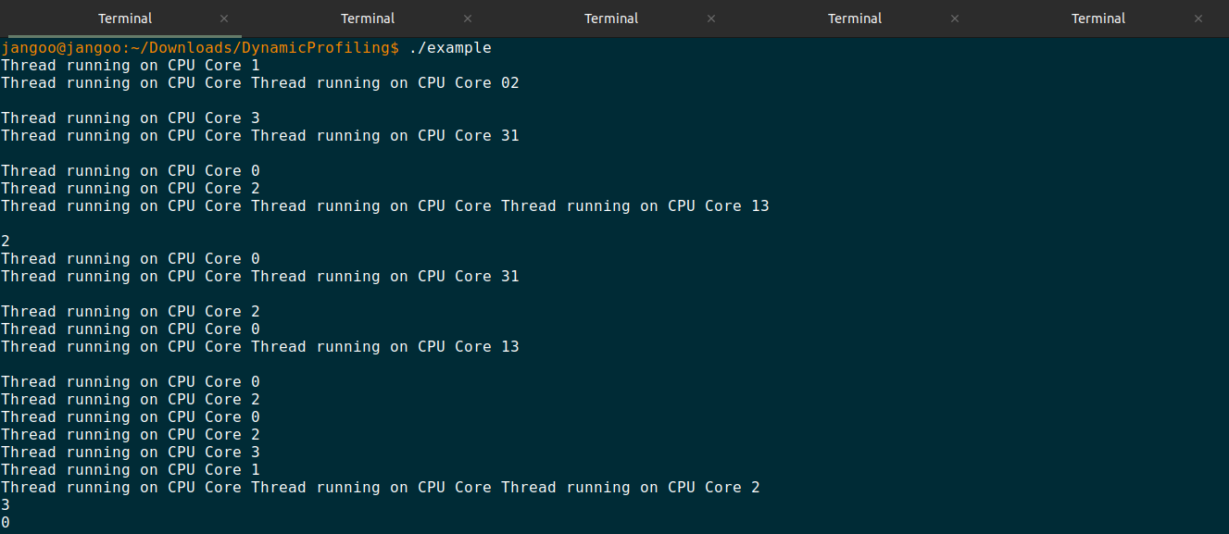
Terminal 2:

Running perf record:
perf recording the metrics of running exe

Command: sudo perf record -g -p 25500

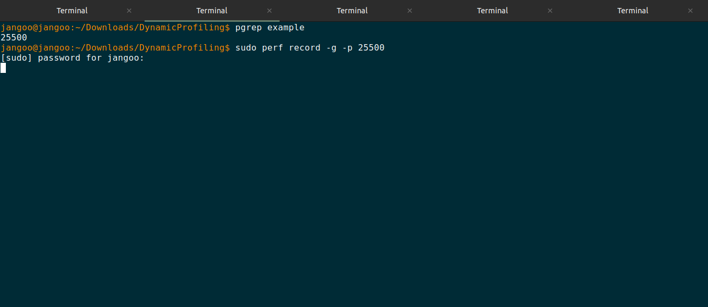
Terminal 3:

Running perf top:
perf top is similar to the top command but uses perf to display a dynamic view of the most consuming functions of the specified process in real-time,highlighting the functions that are consuming the most CPU or resources at any given moment, it provides a snapshot of software-level performance metrics at each interval.

Command: watch -n 1 'sudo perf top -p 25500'

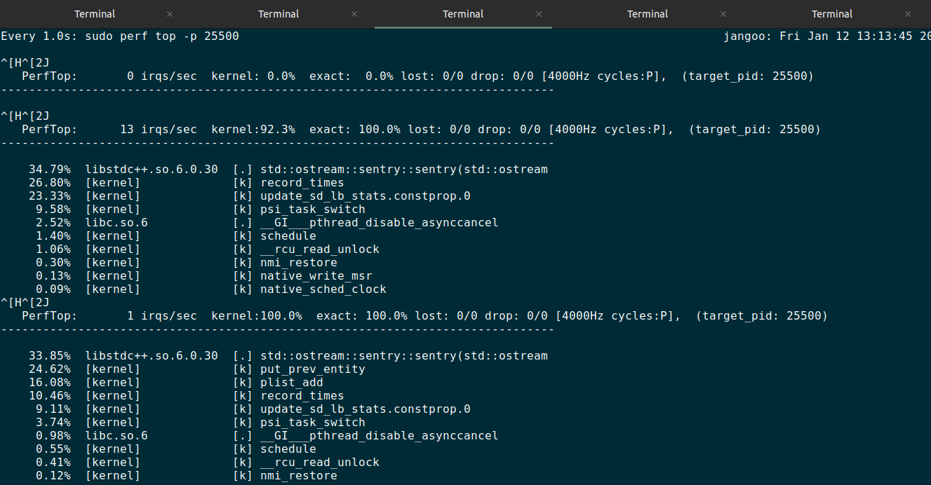
Terminal 4:

Running perf stat:
perf stat provides a snapshot of various hardware and software performance statistics (such as CPU cycles, instructions, context switches, etc, it provides a snapshot of hardware-level performance metrics at each interval, giving an overview of the process's behavior during that time.

Command: watch -n 1 'sudo perf stat -p 25500 sleep 1'

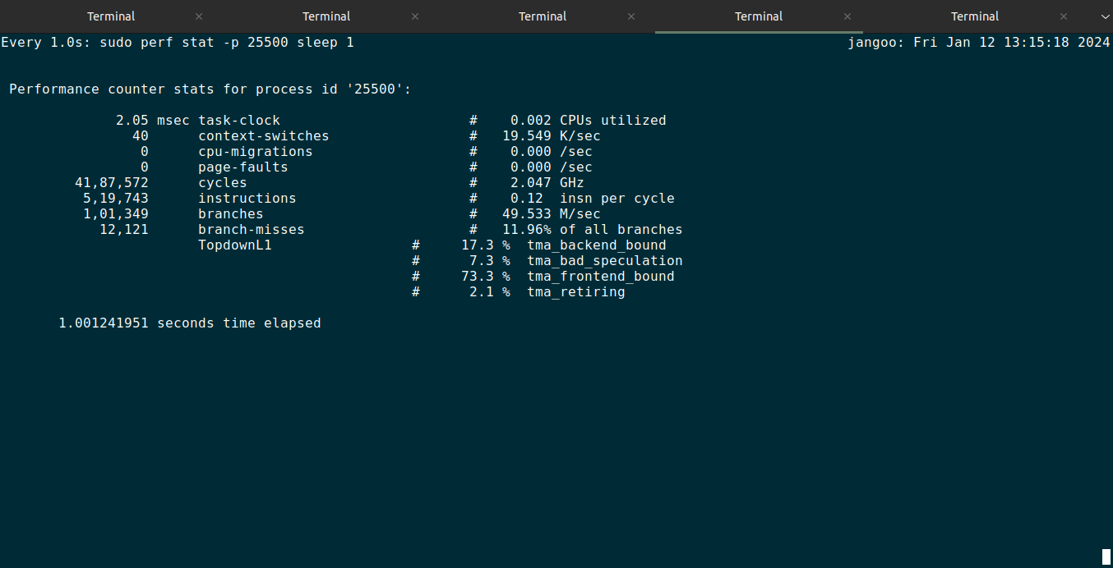

Terminal 5:

Running pidstat:
pidstat provides a broader range of statistics about the process and its interaction with the system, providing information including CPU utilization, memory, I/O, and more, at a system and process level.

Command: pidstat -p 25500 1

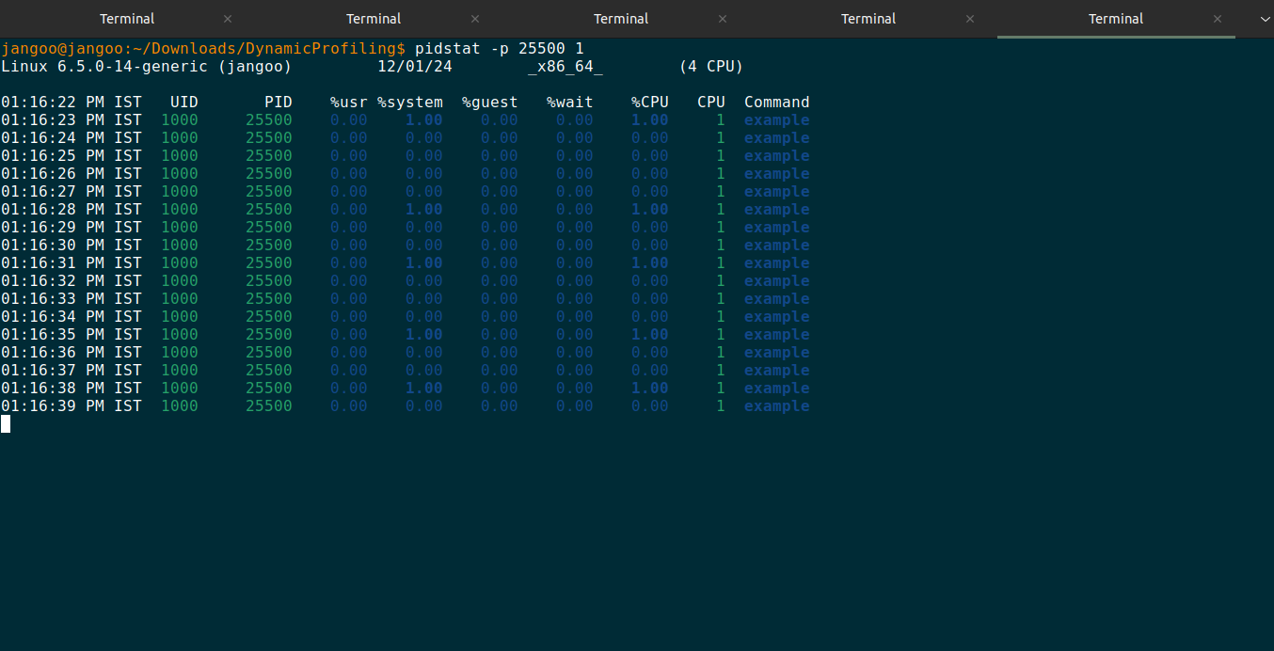

Profiling on exe that exits itself after running (1)
Running perf report:
perf report gives you information about the samples collected during profiling like Samples and Events, Function Call Stacks, Hierarchy, Symbols and Shared Objects, Library Functions, Kernel Functions, User-Space Functions.

perf after exe ran and created perf.data
Command: Sudo perf report -i perf.data

Output:

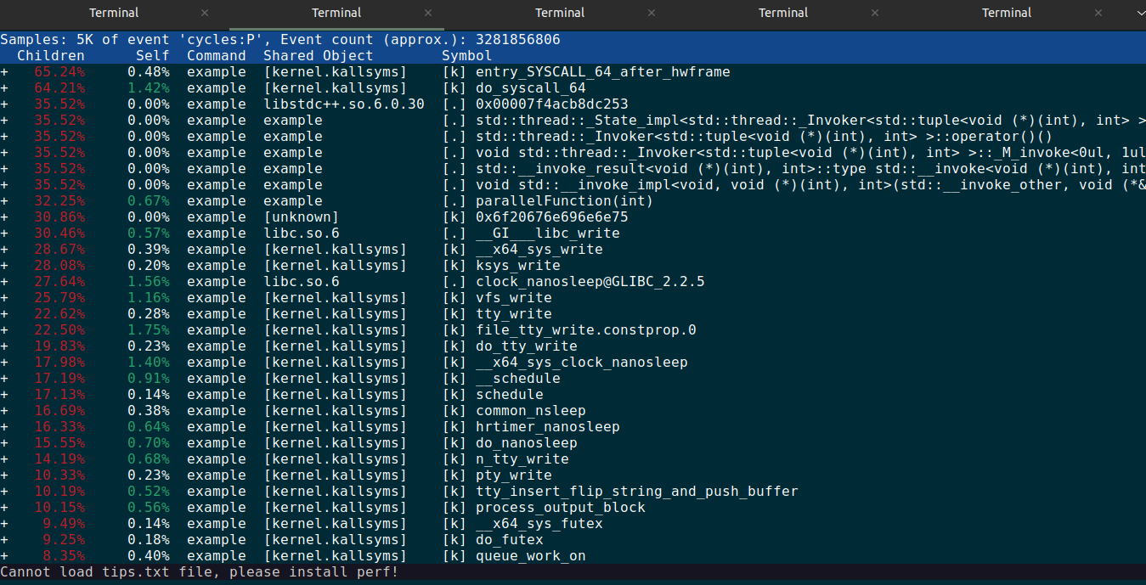
Profiling on exe that exits itself after running (2)
Tool used – gprof

Commands:
1. g++ -o example example.cpp -pg
2. ./example // it will create gmon.out
3. gprof example gmon.out > analysis.txt //convert into redable format

Output:

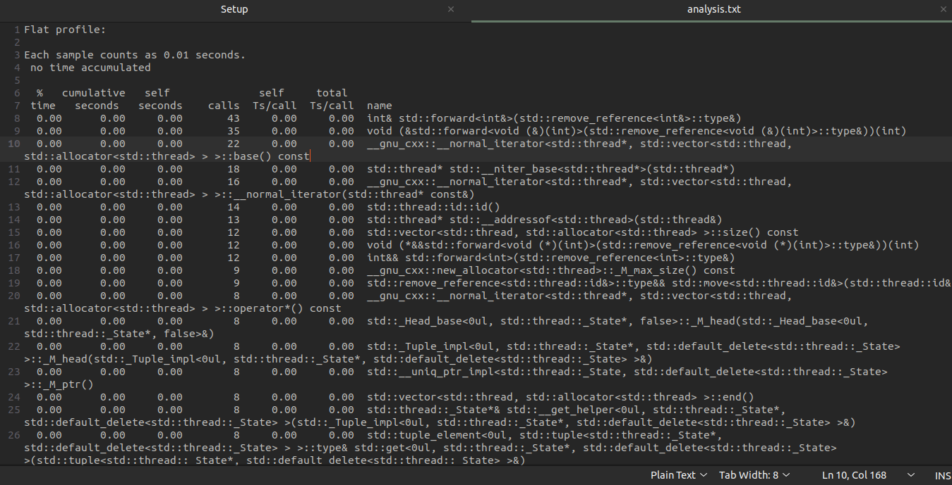
Graphical Output using FlameGraph

After closing/self exiting of exe perf.data is generated

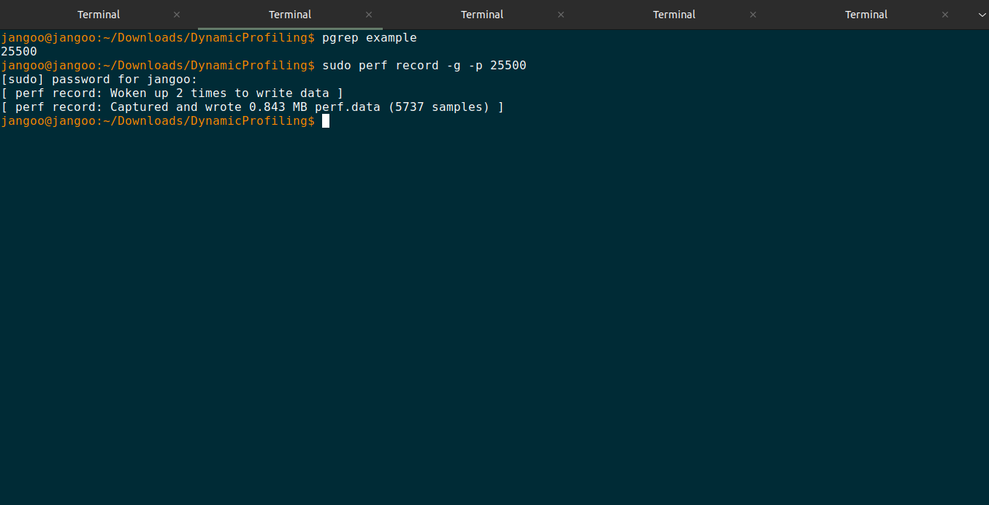
displaying perf.data into FlameGraph

Command: sudo perf script | ~/FlameGraph/stackcollapse-perf.pl | ~/FlameGraph/flamegraph.pl > perf.svg

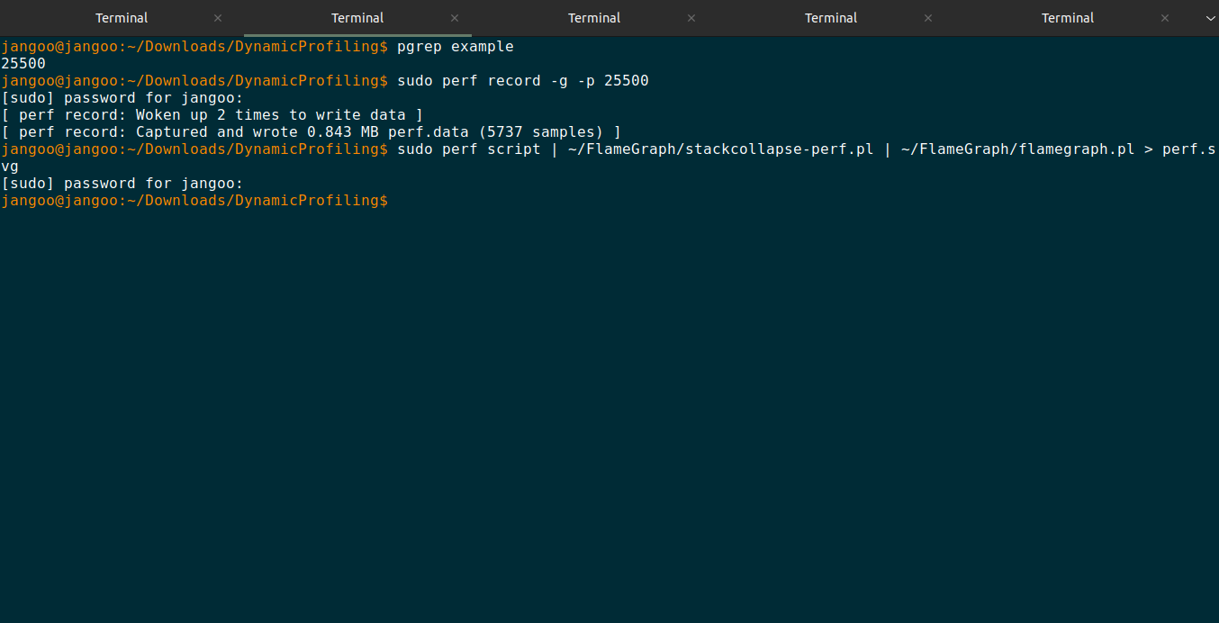

The Output in svg file:

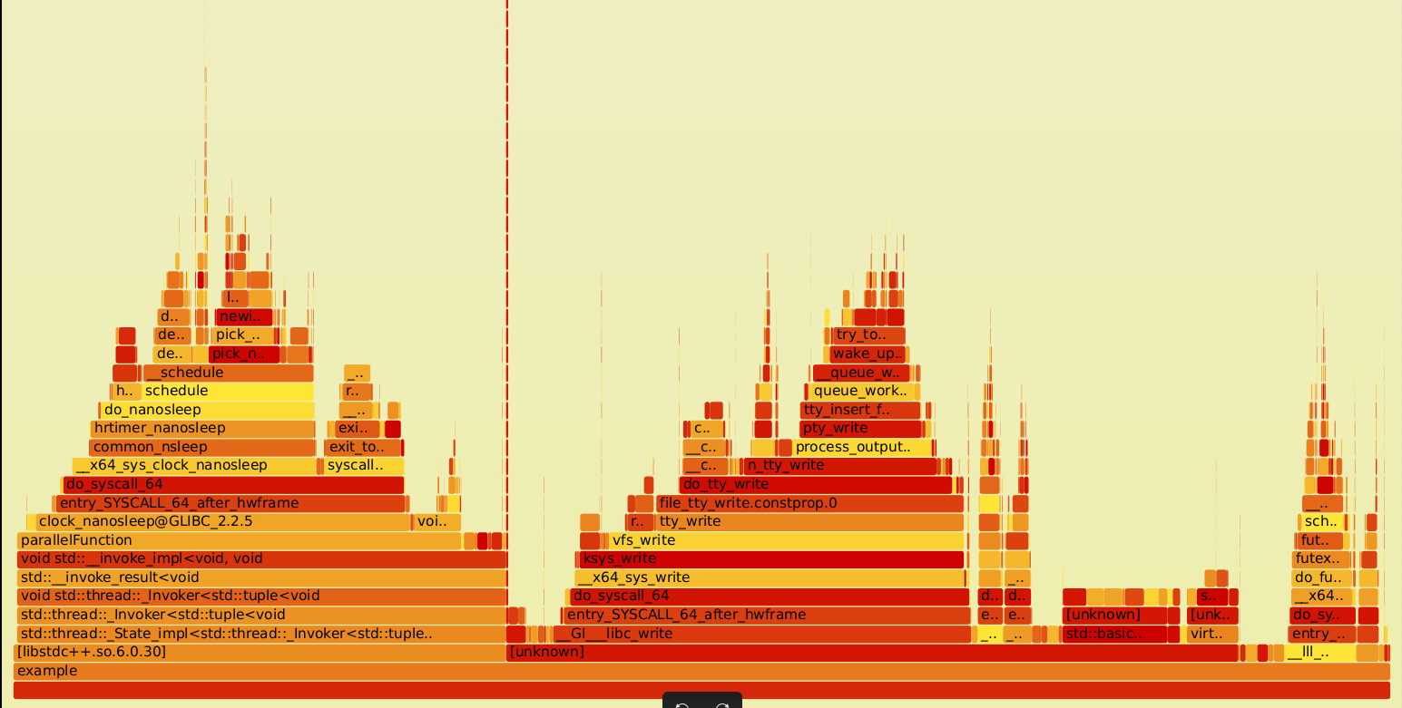
Graphical Output using gprof2dot

Command: ~/.local/bin/gprof2dot -f perf < processed_perf.data | dot -Tpng -o output.png

Generating using gprof2dot

After closing/self exiting of exe perf.data is generated

Command: sudo perf script -i perf.data | gprof2dot -f perf | dot -Tpng -o output.png

Output:

